Setup minikube at your local and explore creating namespaces

(Go through official documentation)

Install Minikube and kubectl:

1. Update the package list: sudo yum update -y

2. Install Docker: sudo yum install docker -y

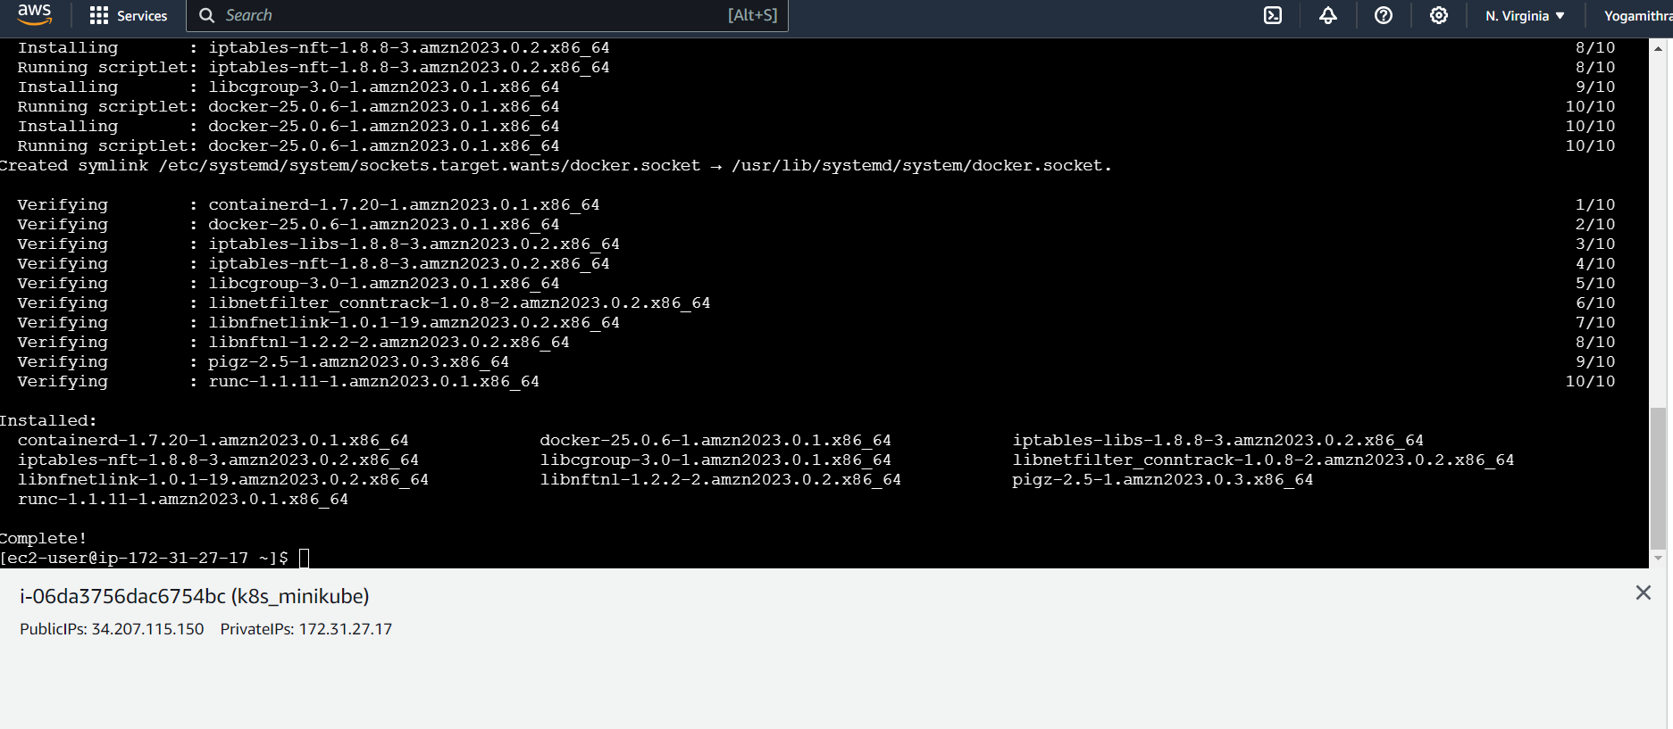

3. Start Docker: sudo systemctl start docker

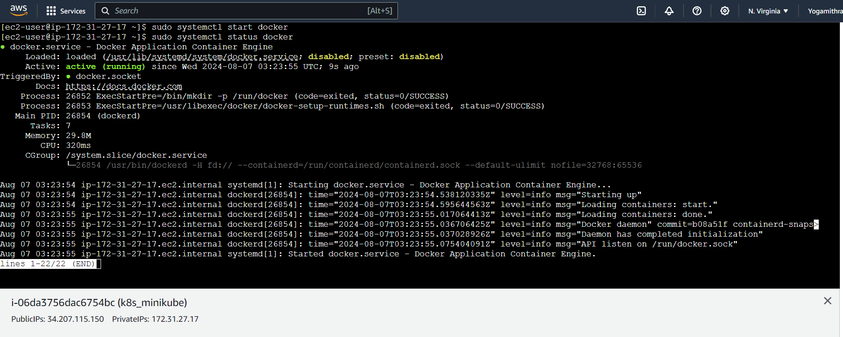

4. Install Minikube:

sudo curl -Lo minikube https://storage.googleapis.com/minikube/releases/latest/minikube-linux-amd64

sudo chmod +x minikube

sudo mv minikube /usr/local/bin/

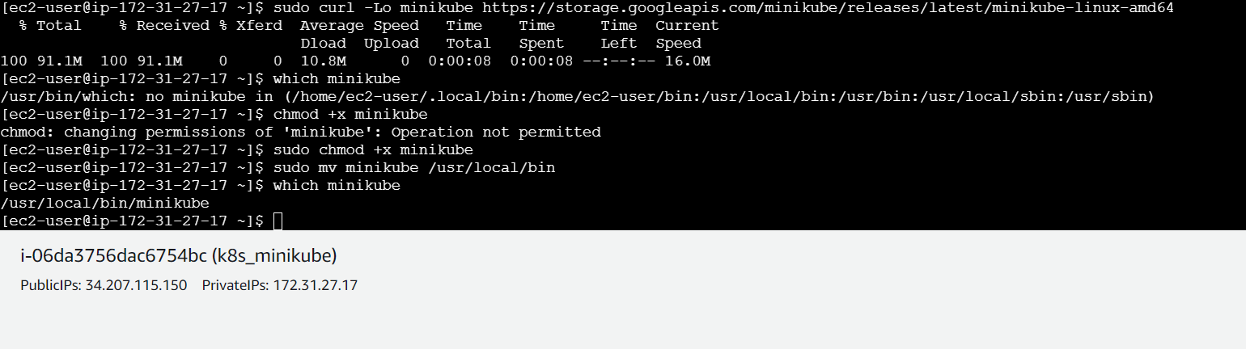

5. Install kubectl:

sudo curl -Lo kubectl https://storage.googleapis.com/kubernetes-release/release/$(curl -s https://storage.googleapis.com/kubernetes-release/release/stable.txt)/bin/linux/amd64/kubectl

sudo chmod +x kubectl

sudo mv kubectl /usr/local/bin/

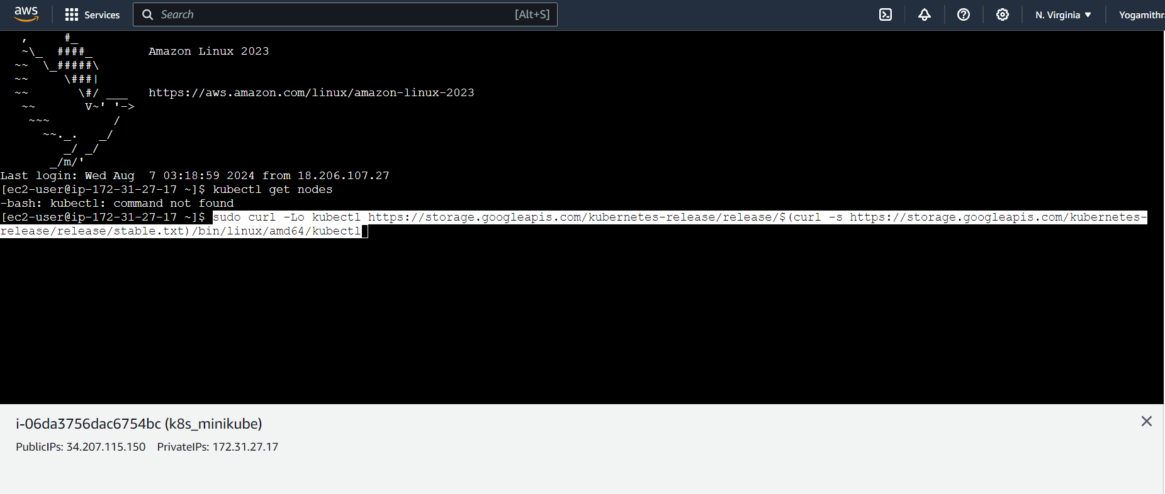

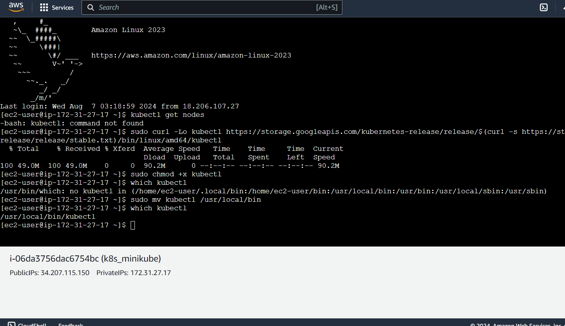 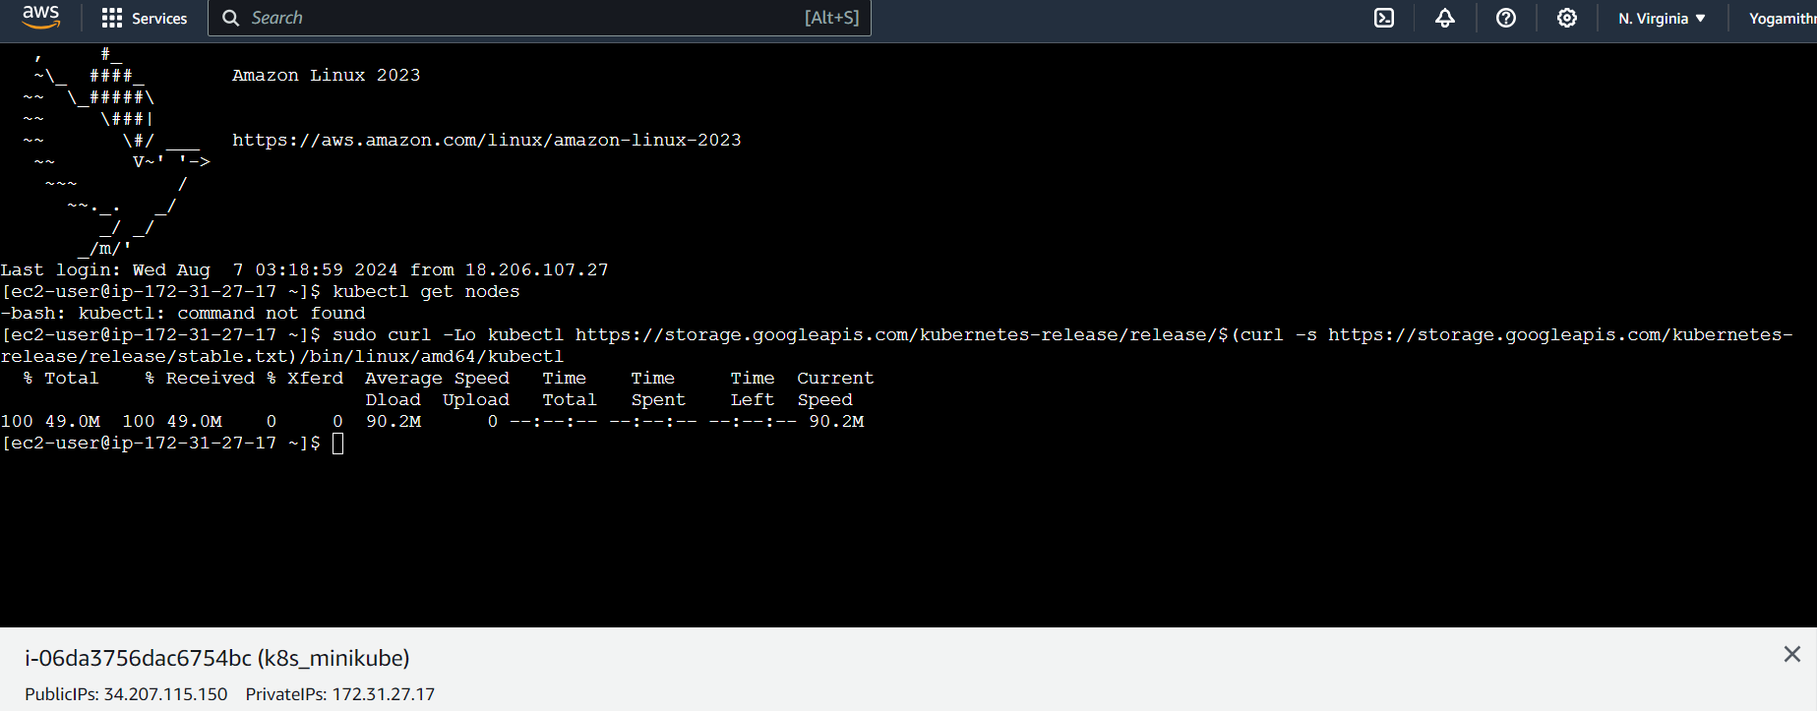

Start Minikube:

minikube start

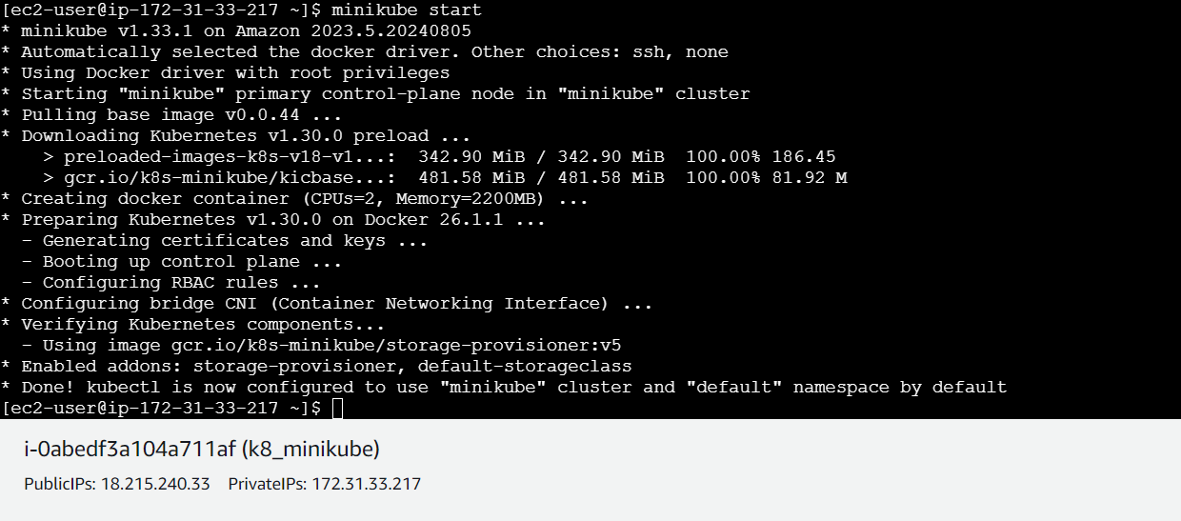

Verify kubectl configuration:

kubectl get nodes

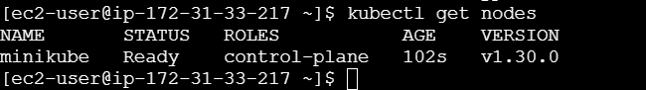

Working with namespaces:

Create a namespace: kubectl create namespace k8-space

